//Stateful & Session Authentication

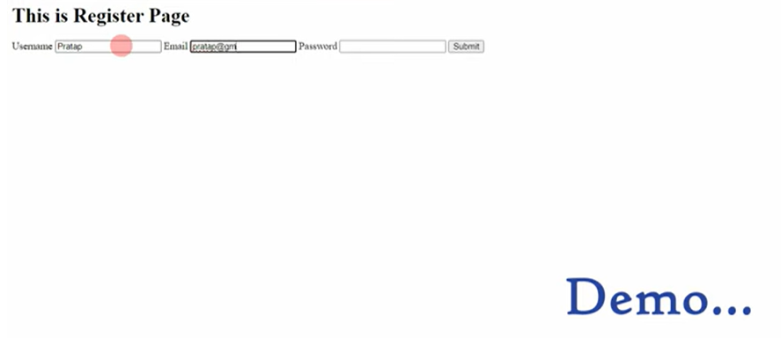

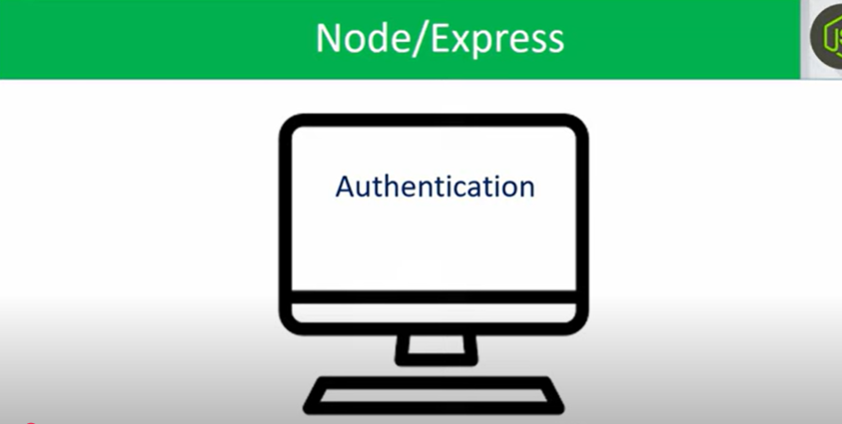

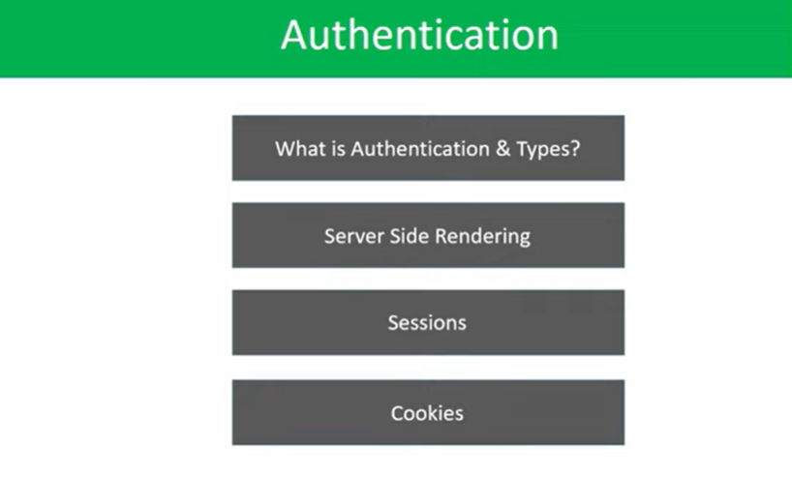

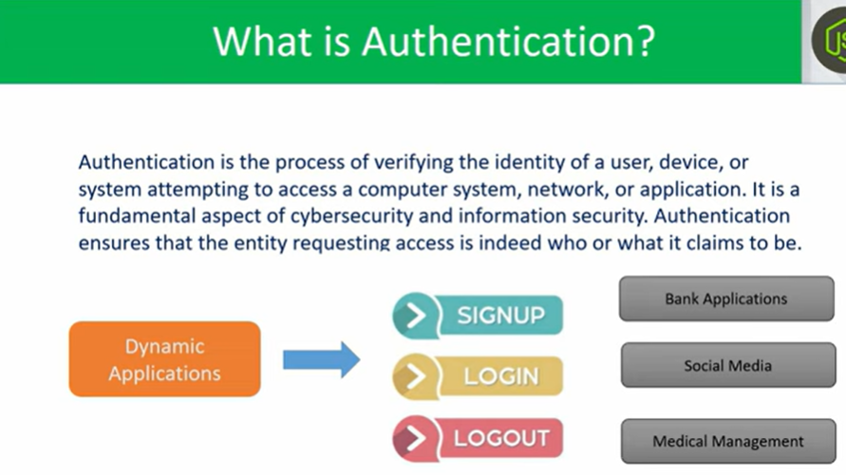

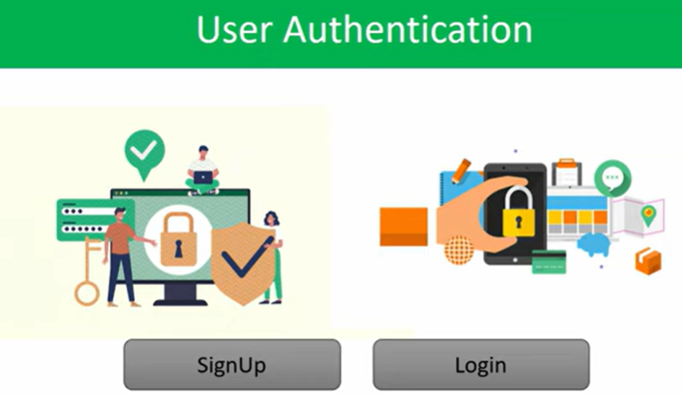

//By signup & login, we can verify the identity of a user i.e called user authentication.

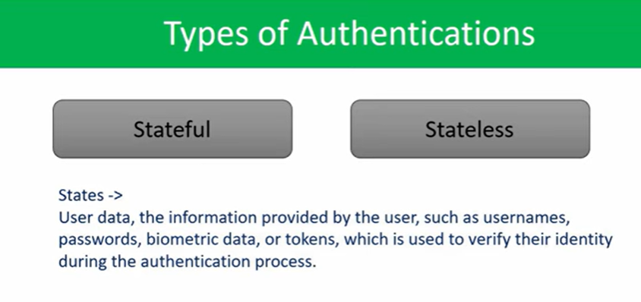

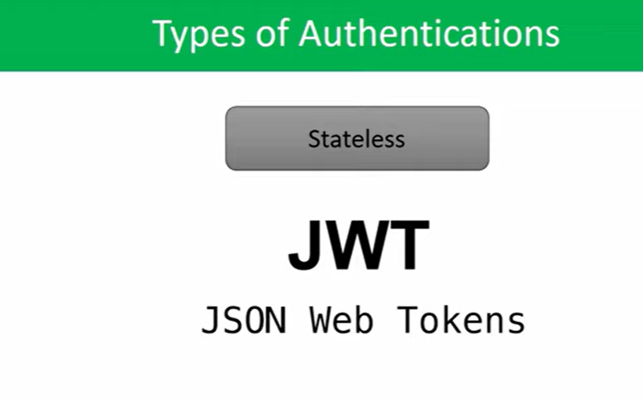

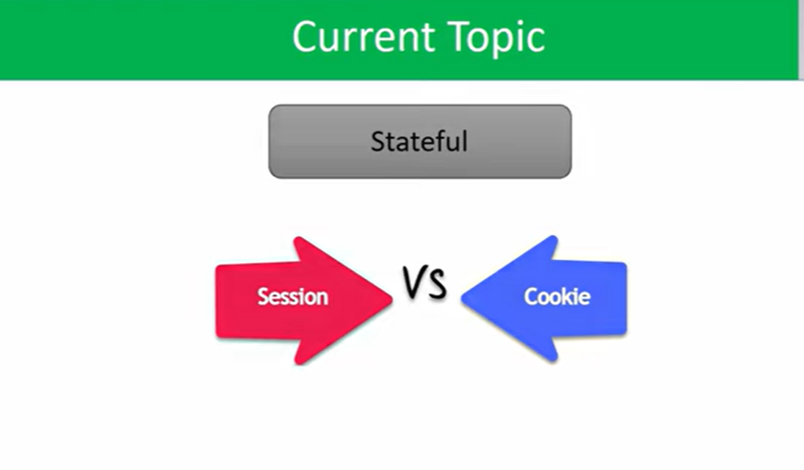

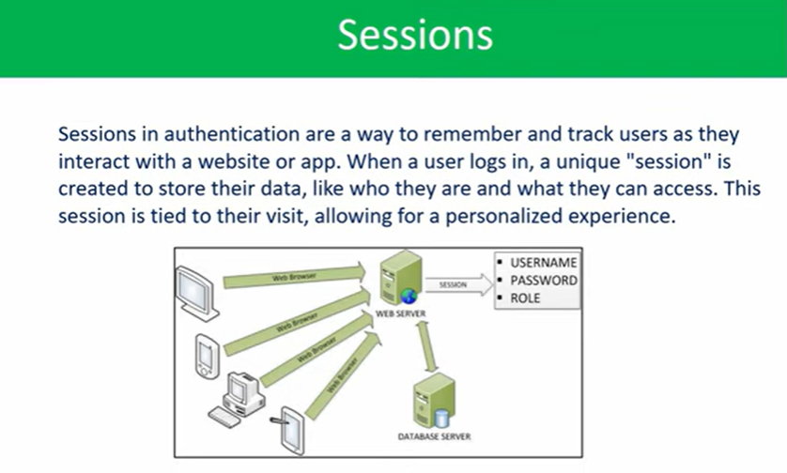

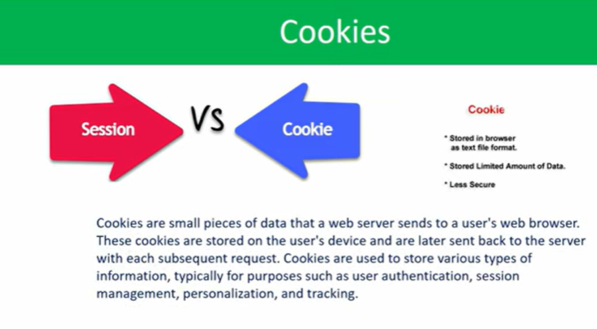

//stateful authentication

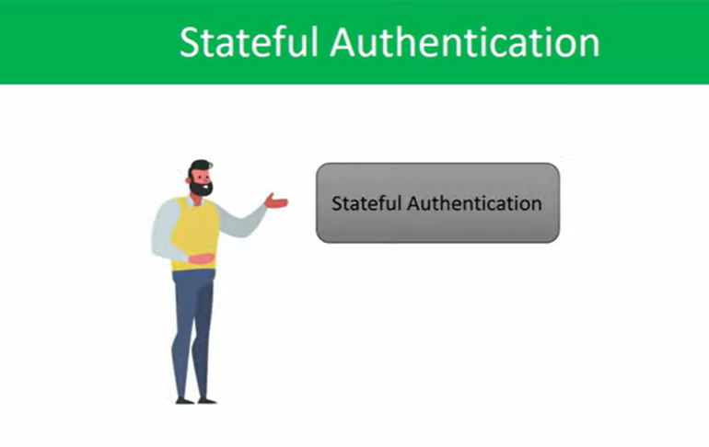

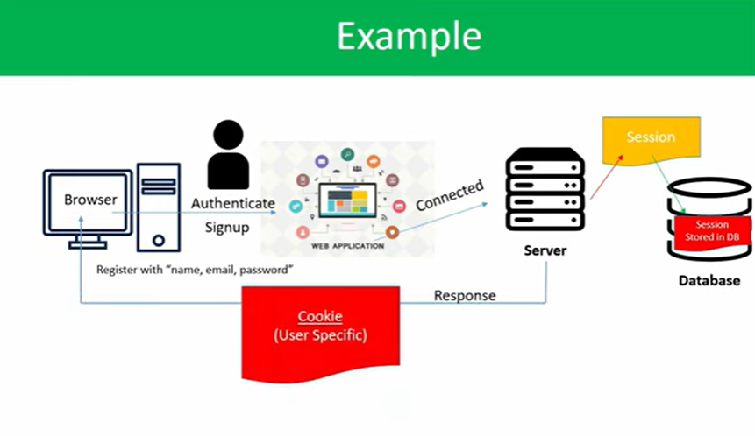

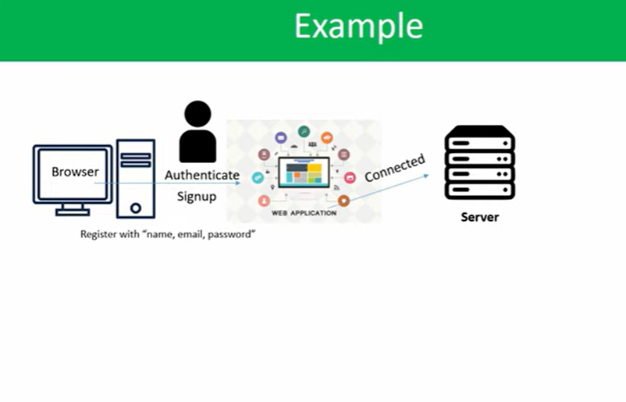

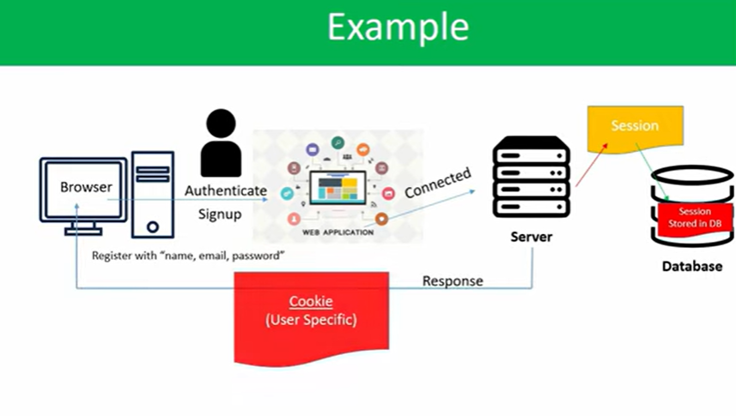

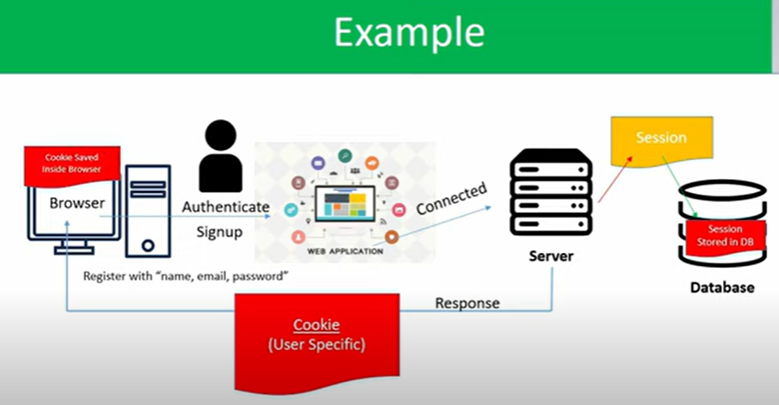

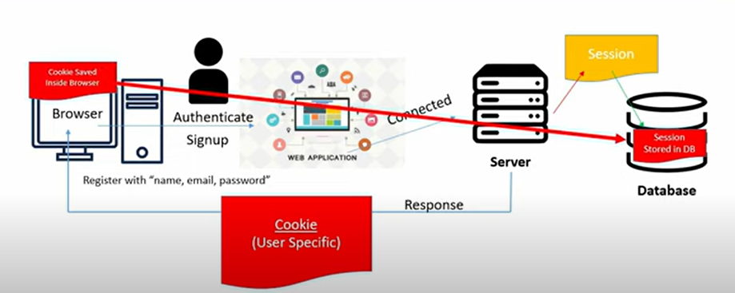

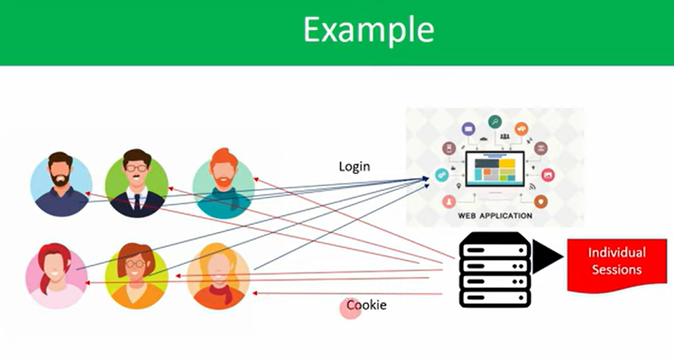

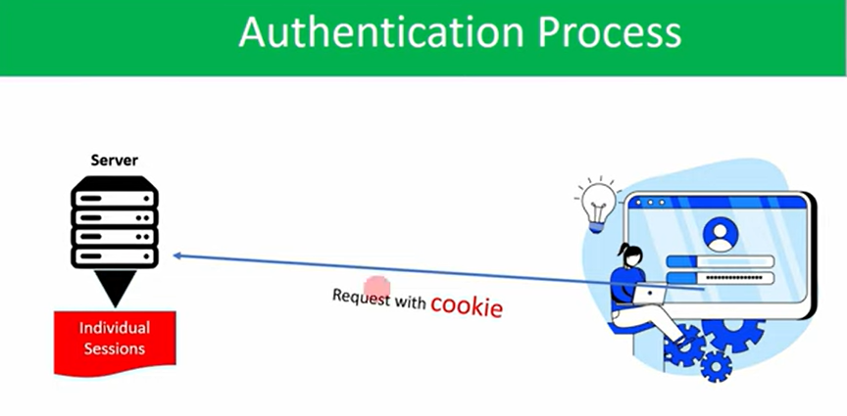

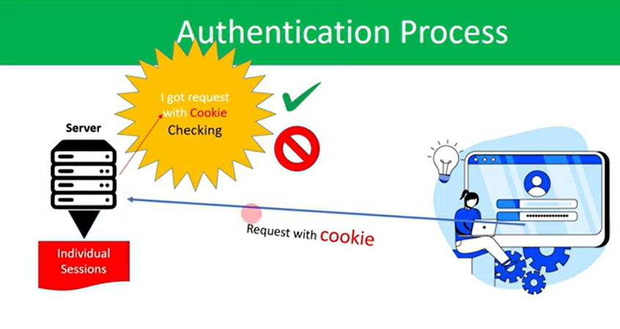

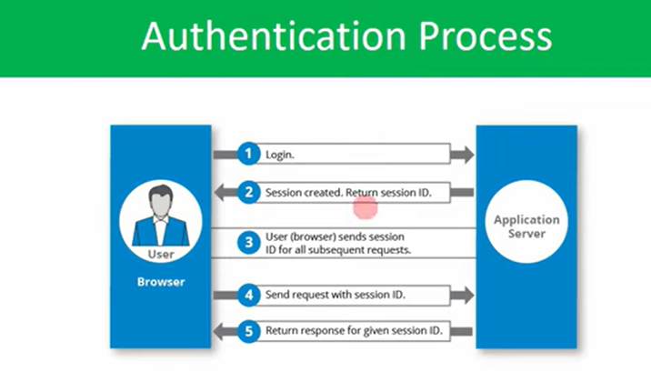

//whenever we done one logout, then the cookie, which created for our login that will break,

//when we login again, then new cookie will be created for our login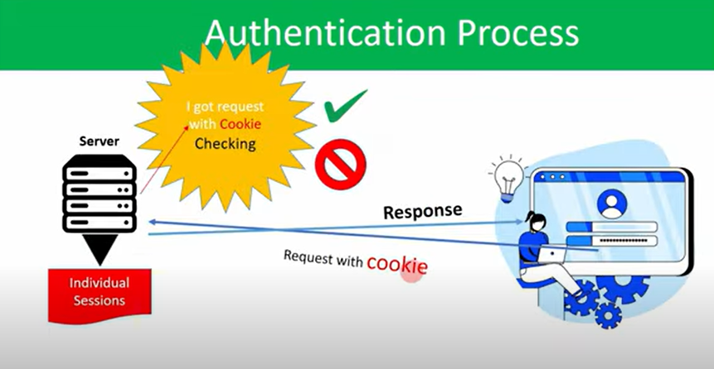

//without cookie we can’t login

//That cookie will be provided by session in Authentication

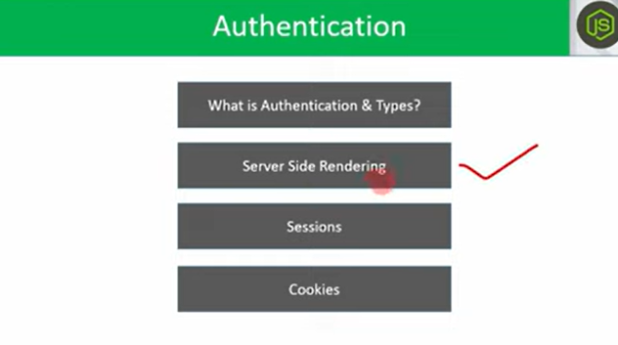

//Server Side Rendering

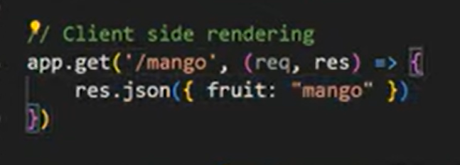

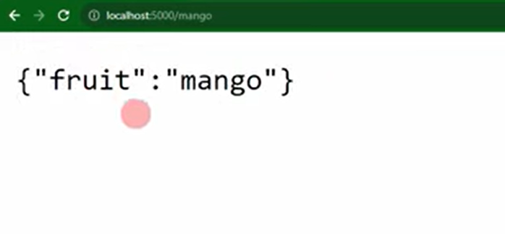

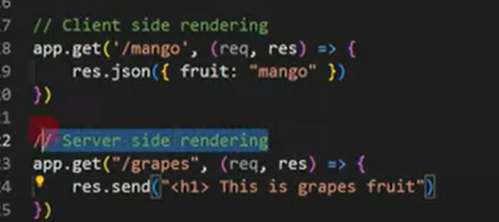

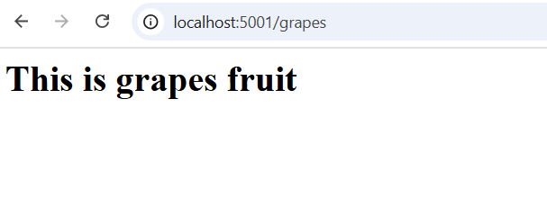

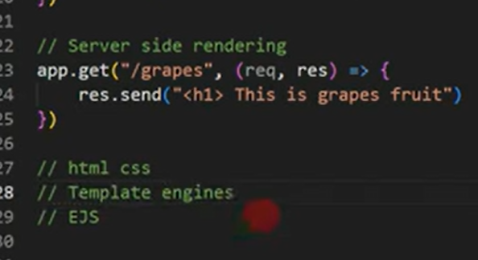

//Whatever the code , we sending from response of server, we have multiple web pages in frontend, so to handle these we have to ‘Template engines’,

//EJS is one of the Template engines

//client side rendering

app.get('/mango', (req, res) => {

    res.json({fruit:"mango"})

})

//server side rendering

app.get("/grapes", (req, res)=>{

    res.send("<h1> This is grapes fruit")

})

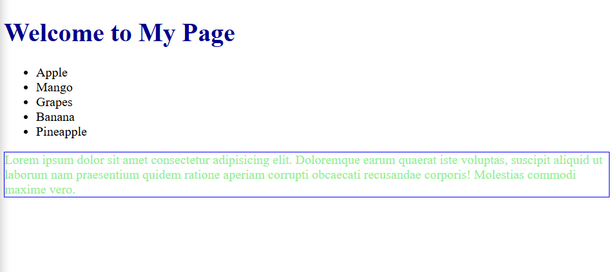

//In server side rendering we can create the n no.of e.j.s pages, based on the request server can send these ejs pages to user.

//These server side rendering we can apply in the authentication.

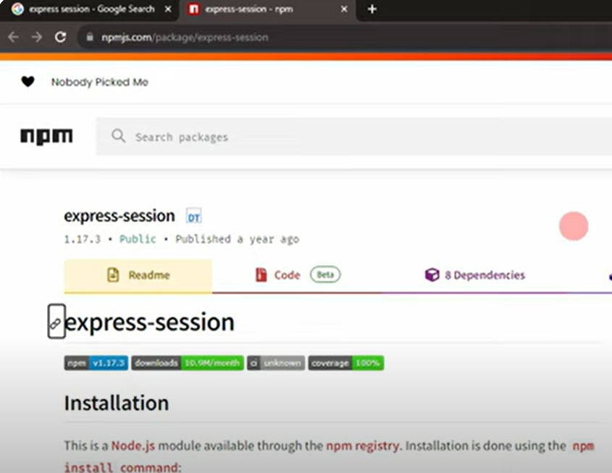

//We have to install the express-session package in our project to implement the session authentication

//1.import the express-session in your project

//2.register the session, by using the middle ware

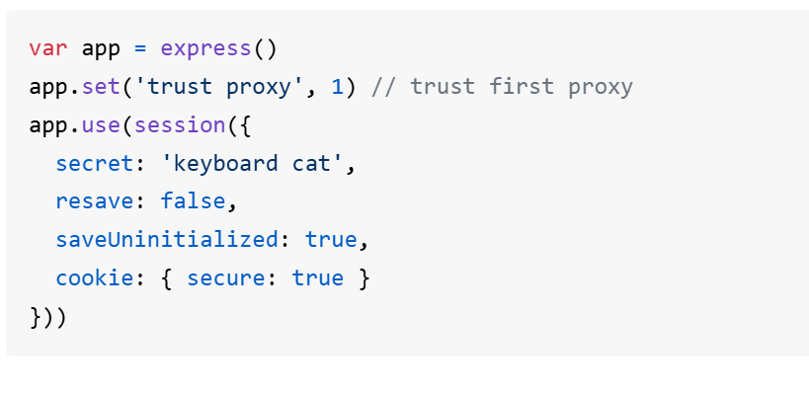

//whatever the session we created to store these session in mongoDB ,we need a package

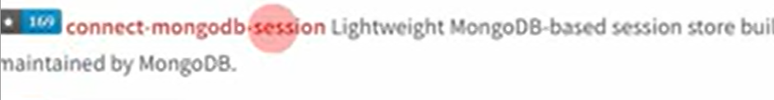

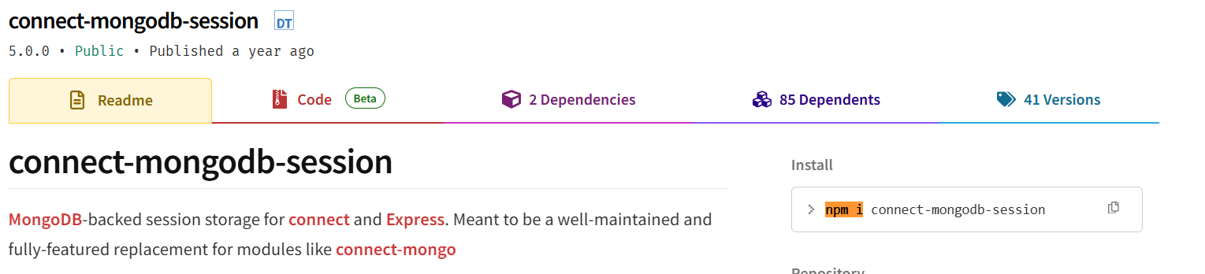

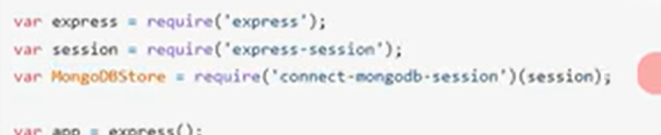

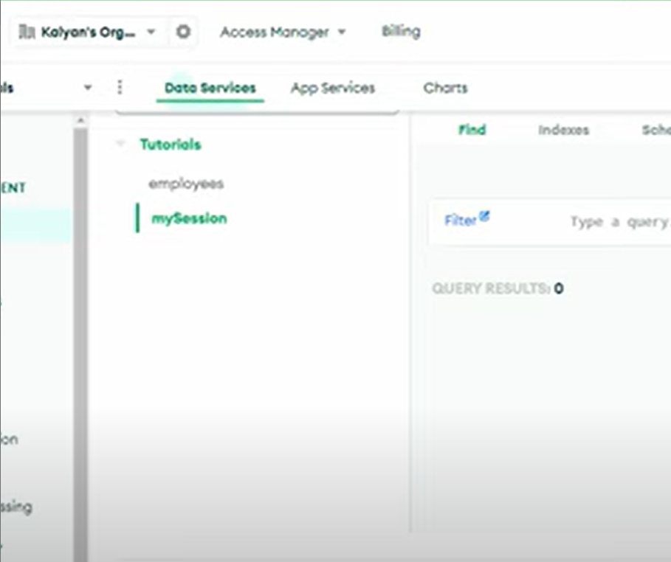

//We created a session in server, that sessionwe stored in mongoDB with name ‘mySession’

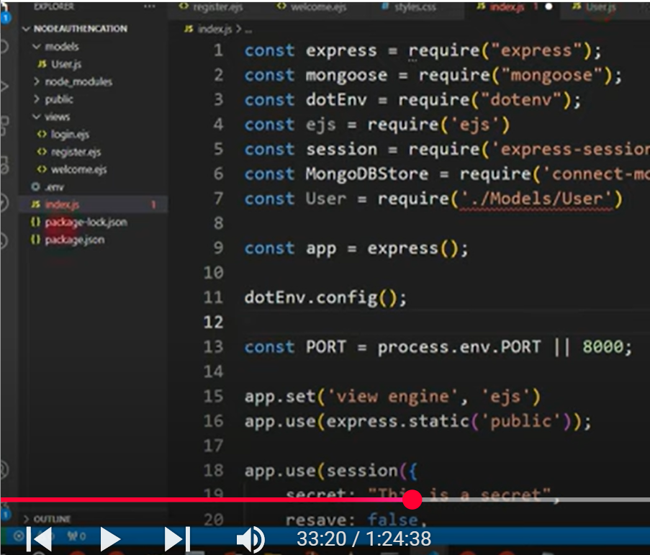

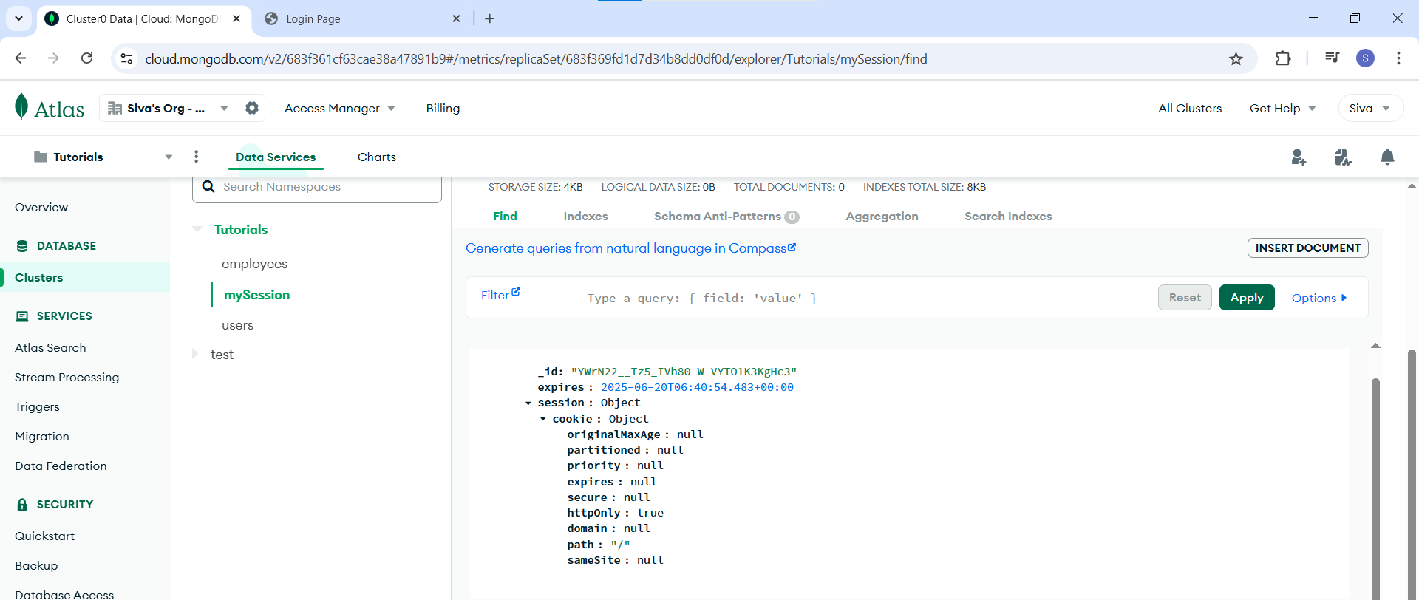

//Whenever we are registered, in an app, then for that user a session will be created and that session is stored in database.

const session = require('express-session')

//2.By using a middle ware we have to register the express-session

// app.use(session({

//     secret: "This is a secret",

//     resave: false,

//     saveUninitialized: true,

// })) //whatever the session we created to store these session in mongoDB ,we need a package

//These session we have to store in store.

const MongoDBStore = require('connect-mongodb-session')(session); //nstall and import the connect-mongodb-session  , and under the function we passed the session to MongoDBStore variable in which we import the 'connect-mongodb-session;

//Whatever the session, we registered by using the middleware, to store that session in mongodb, we will use the MongoDBStore

//Now we have to create  a store

const store = new MongoDBStore({

    uri: process.env.MONGO_URI,

    collection: "mySession"

})

//Lets store these store in session

app.use(session({

    secret: "This is a secret",

    resave: false,

    saveUninitialized: true,

    store: store

}))

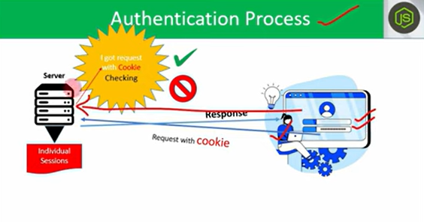

//Cookies will be stored in client side

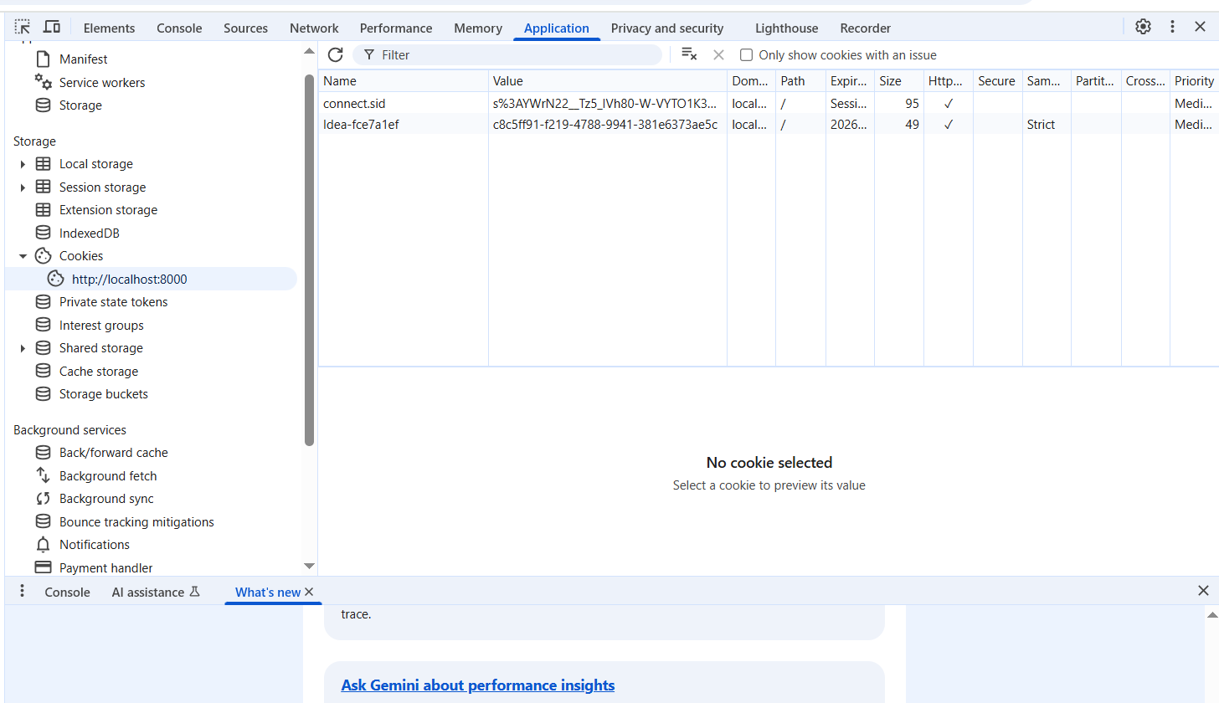

//whenever user logout then session will be destroyed, and cookies will be invalid

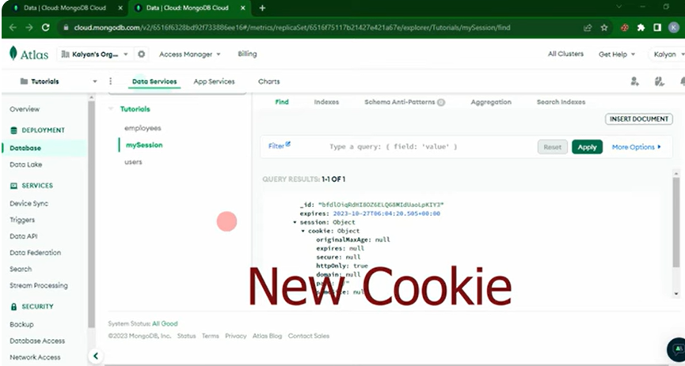

//for one user only one cookie will be storied in one browser

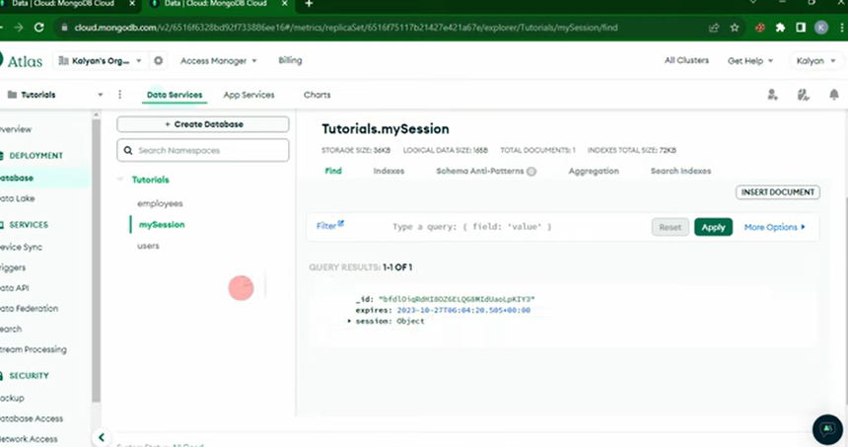

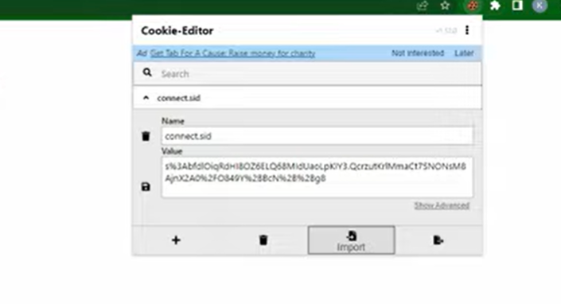

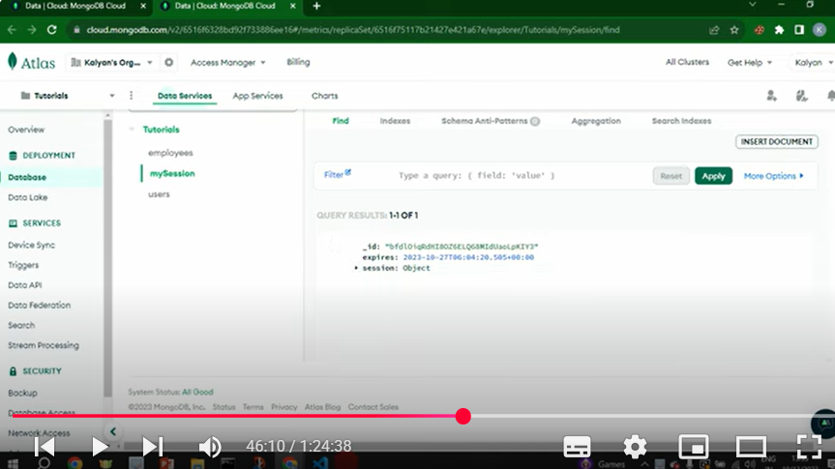



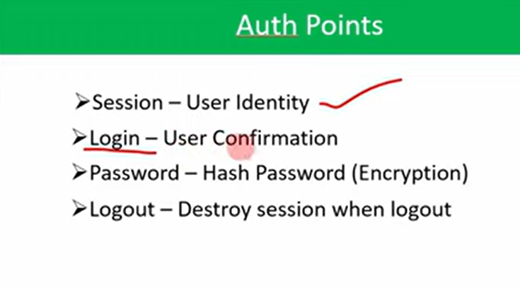

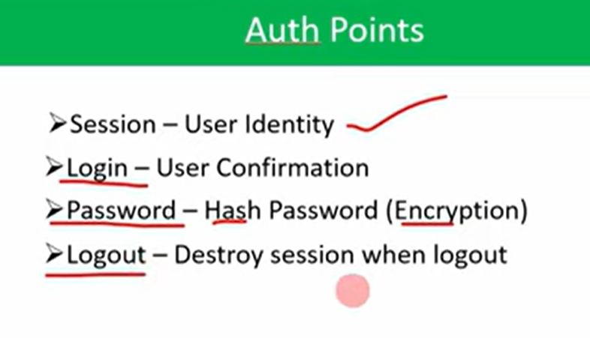

//Now we have to hash the password by using the decrypting

1.server side rendering

2.ejs

3.views

4.project setup

5.installations

6.session store

7.model

8.routes

9.collections

10.sessions

11.cookies

12.test

13.Auth setup

14.hash password

//Now we have to hash the password by using the decrypting

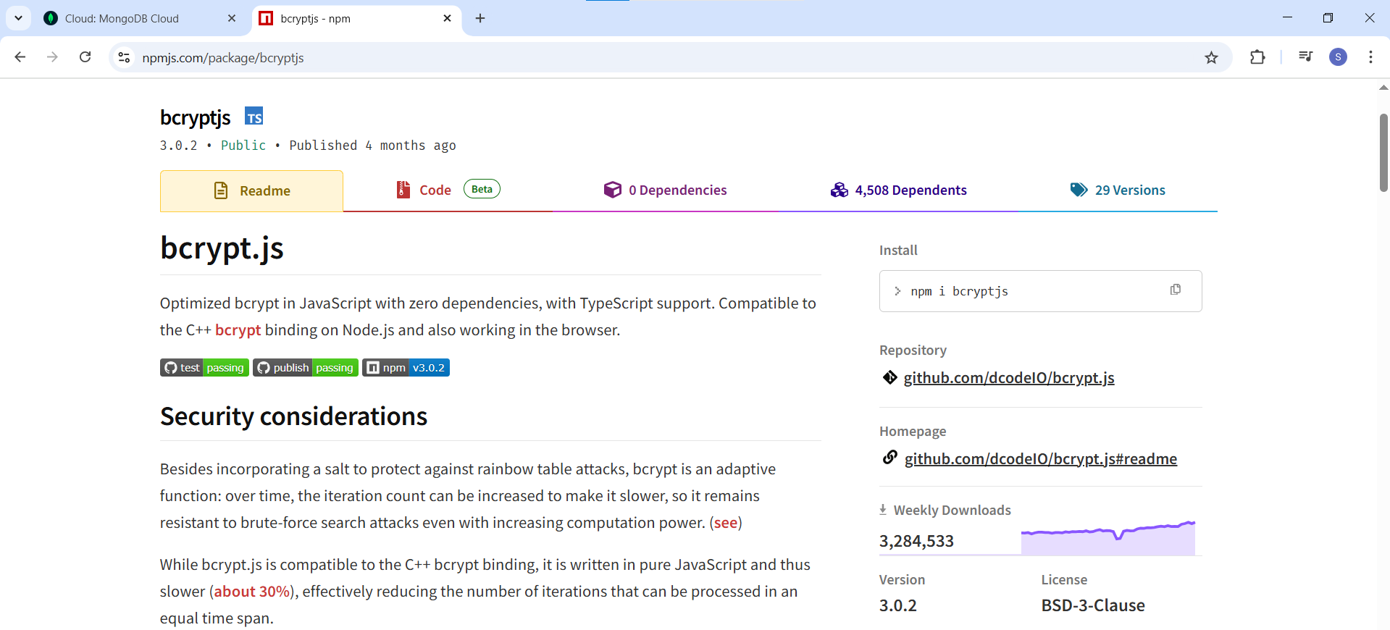

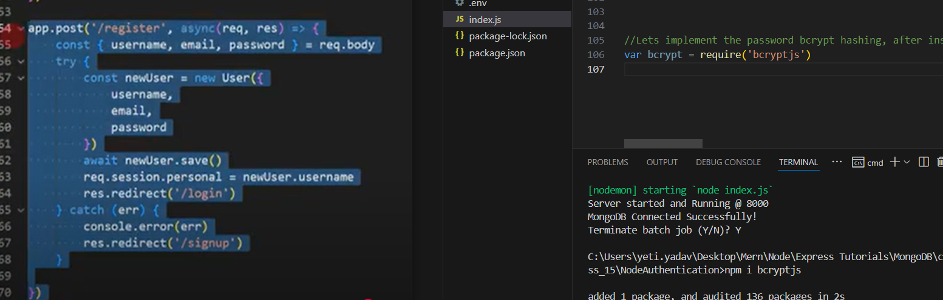

//we have to apply the hashing on our password and store in database

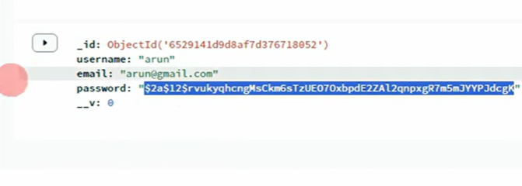

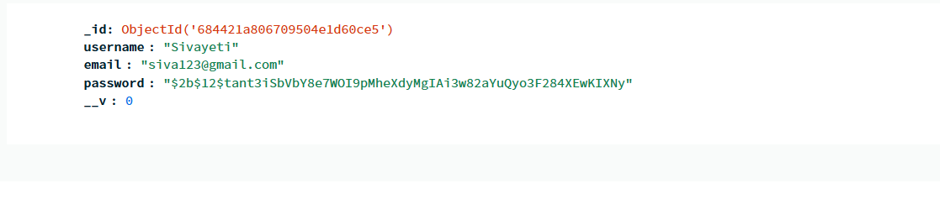

//15.login

//I want to implement the login function

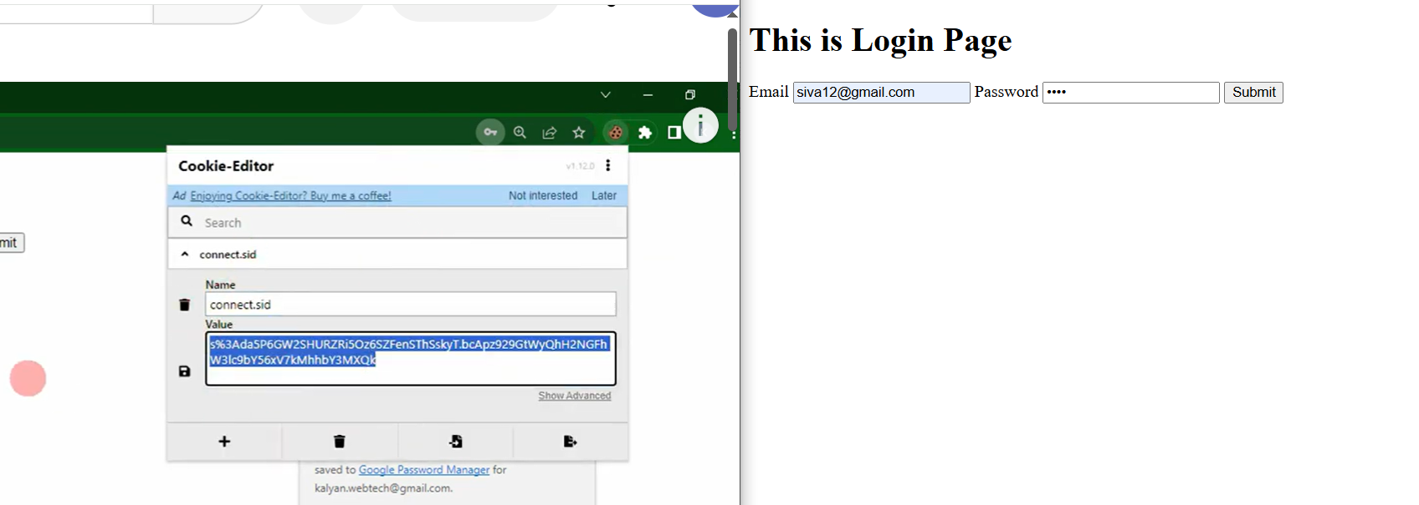

//By using the localhost:8000/dashboard , even without login we are getting into the dashboard to avoid these we have to use the middleware

16.middleware

//17.logout

//lets implement the logout functionality, and also leads to delete the session from mySession in mongodb

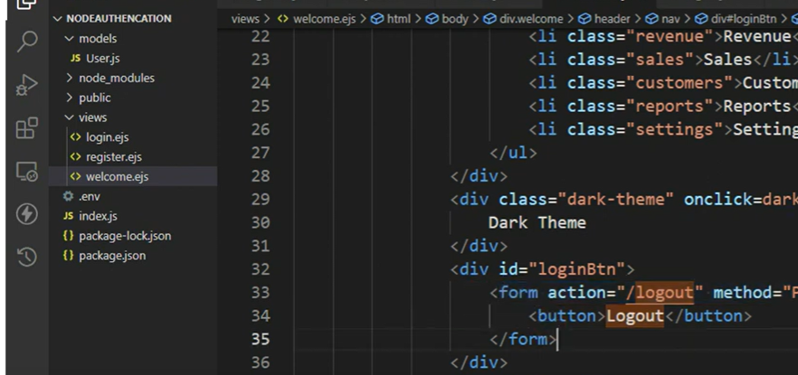

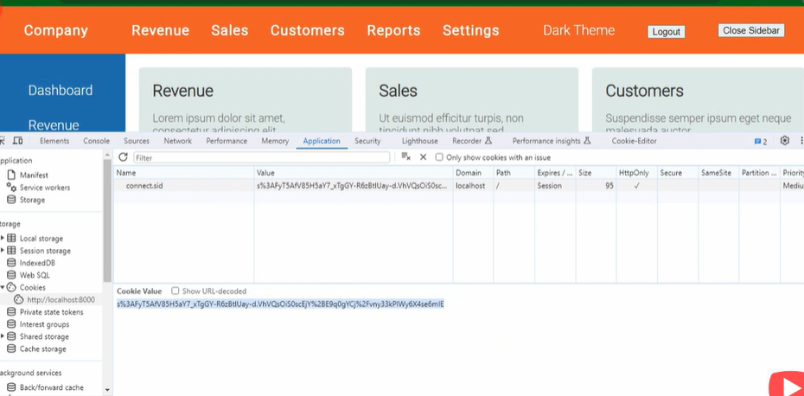

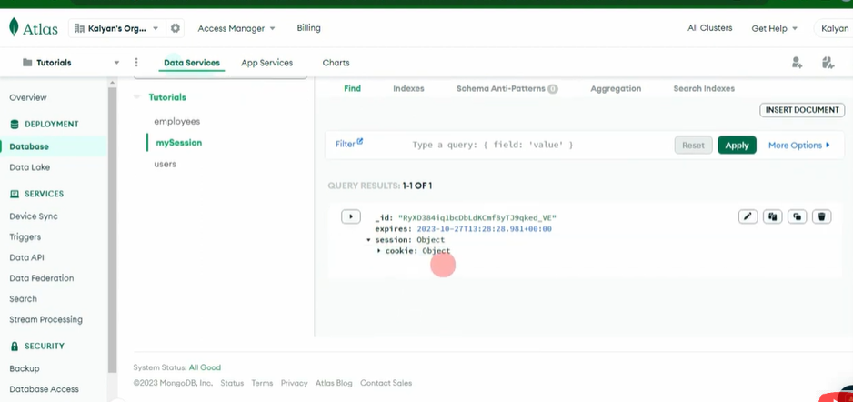

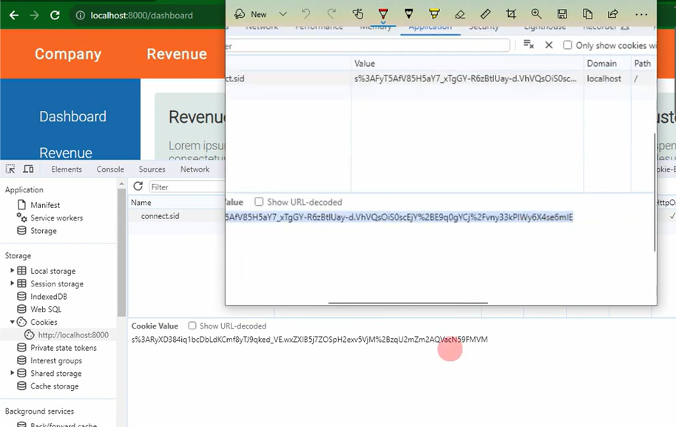

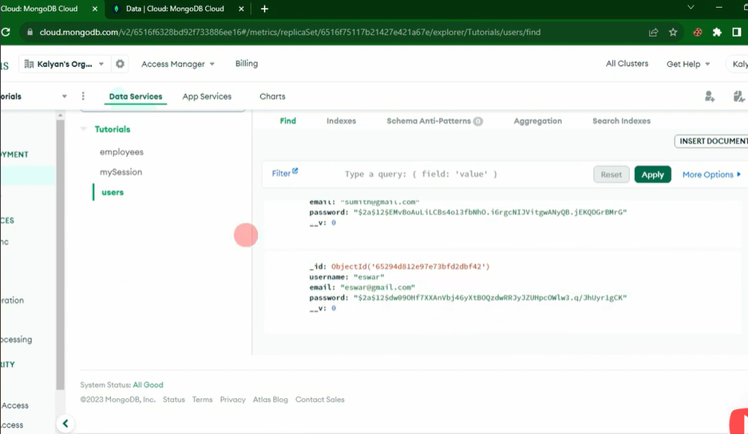

**//Use the expression-session documentation to implement the authentication in MERN**